Dear Community Partner,
2024 RANCH FOOTBALL SPONSORSHIP GUIDE

We would love to offer you the opportunity to partner with the Highlands Ranch High School Football Program. As a sponsor, not only will you be supporting the youth in Highlands Ranch, but you will also gain business recognition throughout our community.

As a sponsor, you will have the opportunity to:

Have your ad in our high-quality, glossy media guide distributed to parents, students, teachers, and fans at every Varsity, JV, and Freshman home game. Have your business recognized on our website, Twitter, Instagram, and Facebook
Have a 4'X8' premium vinyl banner displayed, and your business announced at all HRHS football events, including Falcon Fest, fundraisers, and every home game at Halftime Help Stadium.
Have access to reserved seating and game tickets.

Thank you for supporting Ranch Football and the HRHS Falcon Family!

HRHS Touchdown Club
Highlands Ranch Touchdown Club is a 501(c)(3) non-profit corporation. Contributions to our program are tax deductible and greatly appreciated!

2024 SPONSORSHIP LEVELS
Exclusive MVP Package $2500
8.5x11 Back Cover Ad in Media Guide Logo on Team Schedule Magnets
Full Size Logo on Home Page of Website 4x8 High-quality Vinyl Banner at all events
Ad space on the bottom of game schedule magnets 4 tickets with reserved seating at all home games
Sponsorship announcement and thank you at all events Business mention and link on social media

Championship Package $1500
8.5x11 Inside Cover ad in Media Guide 3/4 Size Logo on Home Page of Website 4x8 High-quality Vinyl Banner at all events
4 tickets with reserved seating at all home games Sponsorship announcement and thank you at all events Business mention and link on social media

All-American Package $1000
8.5x11 Full Page ad in Media Guide 1/2 Size Logo on Home Page of Website 4x8 High-quality Vinyl Banner at all events
2 tickets with reserved seating at home game of your choice Sponsorship announcement and thank you at all events Business mention and link on social media

First-Team Package $500
5.5x8.5 Half Page ad (horizontal) in Media Guide 1/4 Size Logo on Home Page of Website
4x8 High-quality Vinyl Banner at all events Business mention and link on social media

All-Conference Package $300
5.5x4.25 1/4 Page ad (vertical) in Media Guide 1/8 size logo on event T-shirts
1/8 Size Logo on Home Page of Website Business mention and link on social media

Business: Contact: Phone: Email:
2024 SPONSORSHIP AGREEMENT

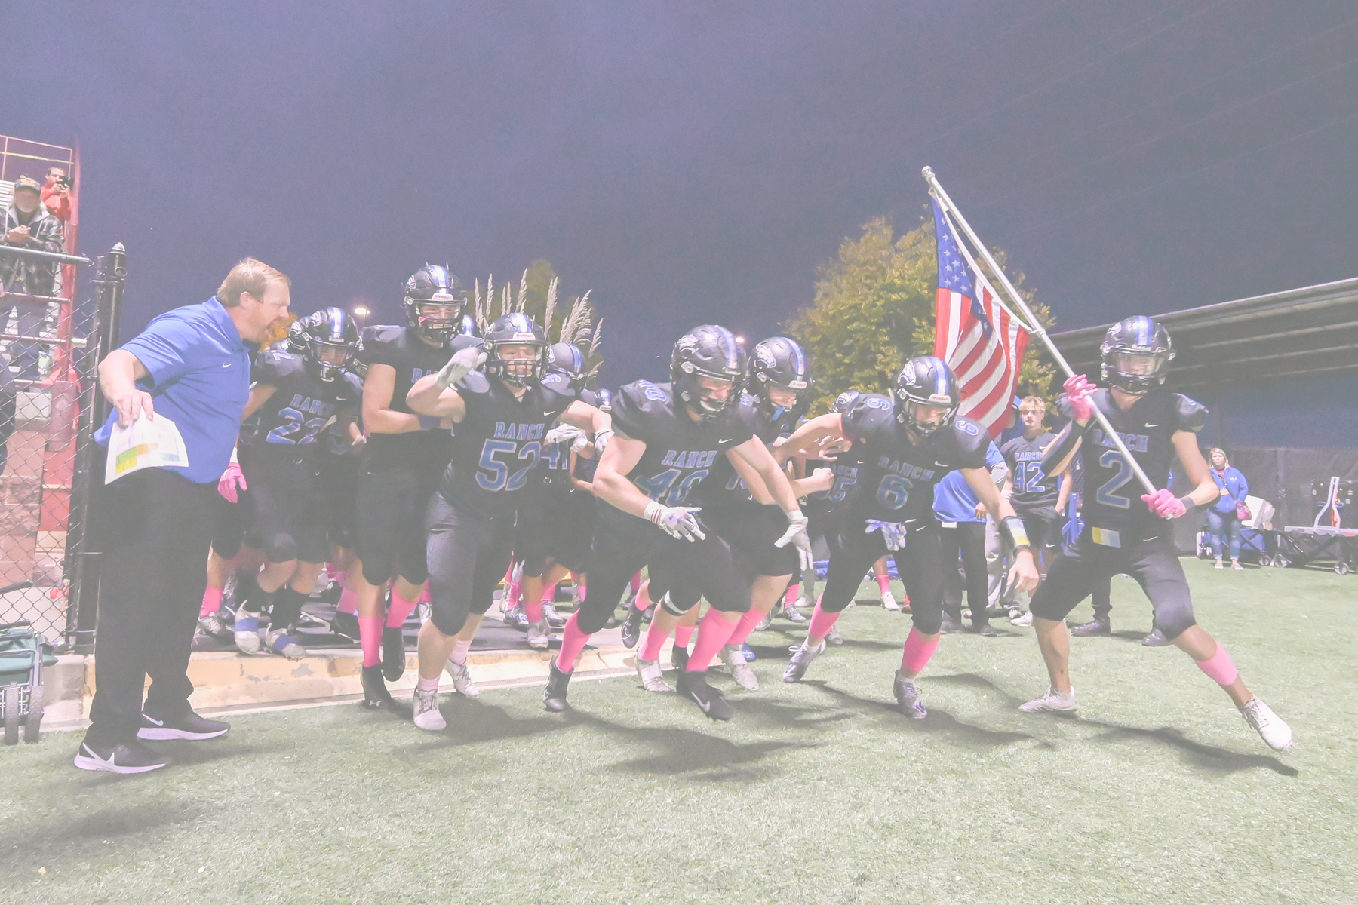
Sponsorship Level
Exclusive MVP $2500 Championship $1500 All-American $1000 First-Team $500
All-Conference $300

Submission & Payment
Submit Sponsorship Agreement, high-quality logo, and any artwork or ad copy to: fundraising@highlandsranchfootball.org
Payments can be made through:
Zelle at treasurer@highlandsranchfootball.org or by check paid to "HRHS Touchdown Club" PO Box 630993
Highlands Ranch, CO 80163-9993

HIGHLANDSRANCHFOOTBALL.ORG

